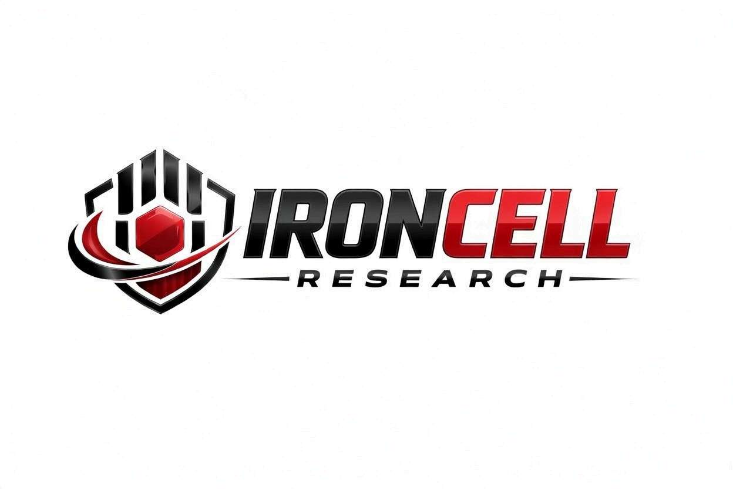
PEPTIDE RESEARCH BRIEF
CJC-1295 (no DAC)
Modified GRF (1-29) | Growth Hormone-Releasing Hormone Analog

Description, Benefits, Dosage & Research Overview

Iron Cell Research
IronCellResearch.com
For Research Use Only


Compound Overview
Compound Name | CJC-1295 without DAC (Modified GRF 1-29 / Mod GRF 1-29)
Classification | Synthetic Growth Hormone-Releasing Hormone (GHRH) Analog
Amino Acid Sequence | Tyr-D-Ala-Asp-Ala-Ile-Phe-Thr-Gln-Ser-Tyr-Arg-Lys-Val-Leu-Ala-Gln-Leu-Ser-Ala-Arg-Lys-Leu-Leu-Gln-Asp-Ile-Leu-Ser-Arg-NH2 (29 amino acids)
Molecular Formula | C152H252N44O42
Molecular Weight | 3367.9 g/mol
CAS Number | 863288-34-0
Biological Half-Life | Approximately 30 minutes (without DAC)
Purity | Greater than or equal to 99%
Storage | Lyophilized, -20C, protected from light and moisture
Research Status | Extensive preclinical research; commonly studied with GHRPs

Description
CJC-1295 without DAC, also known as Modified GRF (1-29) or Mod GRF 1-29, is a synthetic analog of the first 29 amino acids of human growth hormone-releasing hormone (GHRH). Four amino acid substitutions (positions 2, 8, 15, and 27) have been made to improve metabolic stability and resistance to enzymatic degradation by dipeptidyl peptidase-IV (DPP-IV), while preserving full biological activity at the GHRH receptor.
Unlike the DAC (Drug Affinity Complex) version which binds to albumin for an extended half-life of 6-8 days, the non-DAC form has a short half-life of approximately 30 minutes. This shorter duration produces acute, pulsatile GH release that more closely mimics the body's natural GH secretion pattern, which is preferred by many researchers for its physiological profile and reduced risk of sustained GH elevation.
CJC-1295 without DAC is frequently studied in combination with growth hormone-releasing peptides (GHRPs) such as Ipamorelin or GHRP-6, as the two classes of peptides act synergistically on different receptor pathways to amplify GH release significantly beyond what either achieves alone.

Mechanism of Action

GHRH Receptor Agonism
CJC-1295 (no DAC) binds to and activates the GHRH receptor (GHRHR) on somatotroph cells in the anterior pituitary gland. This triggers Gs-protein coupled activation of adenylyl cyclase, increasing intracellular cAMP levels. The resulting PKA activation stimulates GH gene transcription, GH synthesis, and exocytosis of GH-containing secretory vesicles.

Pulsatile GH Release
The short half-life of the non-DAC form produces a sharp, defined GH pulse lasting approximately 2-3 hours, closely replicating the amplitude and duration of natural nocturnal GH pulses. This preserves somatostatin-mediated negative feedback, maintaining normal GH pulsatility and preventing tachyphylaxis (receptor desensitization) that can occur with sustained GH elevation.

Synergy with GHRPs
GHRH (via CJC-1295) and GHRPs (such as Ipamorelin) stimulate GH release through complementary mechanisms: GHRH increases the amplitude of GH pulses while GHRPs increase the number of GH-secreting cells that respond. Additionally, GHRPs suppress somatostatin, removing the brake on GH release. When combined, GH output can be 3-5 times greater than either peptide alone.

IGF-1 Axis Activation
The GH released in response to CJC-1295 stimulates hepatic IGF-1 production and modulates IGF binding proteins. Because the GH pulse is transient and physiological, IGF-1 elevation is moderate and within normal range, supporting anabolic, lipolytic, and regenerative effects without the risks of supraphysiological IGF-1 levels.

Research Benefits

Growth Hormone Optimization
- GH Pulse Amplification: Increases the amplitude of natural GH pulses by 2-10 fold depending on dose and combination with GHRPs.
- Physiological Pattern: Preserves natural pulsatile GH secretion pattern, avoiding continuous GH elevation associated with exogenous GH.
- IGF-1 Elevation: Produces moderate, sustained increases in IGF-1 within the upper physiological range.
- Feedback Preservation: Maintains hypothalamic-pituitary feedback loops, reducing risk of pituitary desensitization.

Body Composition
- Fat Loss: GH-mediated lipolysis promotes visceral and subcutaneous fat reduction, particularly when combined with exercise.
- Lean Mass: Supports muscle protein synthesis through both direct GH effects and IGF-1 mediated anabolic signaling.
- Body Recomposition: Simultaneous fat loss and lean mass preservation, particularly notable in caloric deficit conditions.

Recovery & Tissue Repair
- Connective Tissue: Enhances collagen synthesis in tendons, ligaments, and cartilage through IGF-1 stimulation.
- Muscle Recovery: Accelerates post-exercise recovery and reduces delayed-onset muscle soreness (DOMS).
- Injury Healing: Promotes tissue repair cascades including fibroblast proliferation and angiogenesis.
- Bone Density: IGF-1-mediated stimulation of osteoblast activity supports bone mineral density.

Sleep & Recovery Quality
- Deep Sleep Enhancement: GH is predominantly released during slow-wave sleep; optimizing GH pulsatility may enhance sleep architecture.
- Recovery Optimization: Improved nocturnal GH release supports overnight tissue repair and metabolic restoration.

Anti-Aging & Longevity
- GH Decline Reversal: Addresses somatopause (age-related decline in GH/IGF-1 axis) by restoring youthful GH pulse amplitude.
- Skin Quality: GH and IGF-1 stimulate dermal collagen production, improving skin thickness, elasticity, and hydration.
- Cognitive Support: IGF-1 supports neurogenesis, synaptic plasticity, and neuroprotective signaling in the CNS.

Dosage & Administration
The following dosage information is provided for research reference purposes only.
Protocol | Dose Range | Route | Frequency
Low / Introductory | 100 mcg | SubQ Injection | 1-3x daily (pre-bed, AM, post-workout)
Standard | 100-150 mcg | SubQ Injection | 2-3x daily
With Ipamorelin | 100 mcg CJC + 100-200 mcg Ipamorelin | SubQ Injection | 2-3x daily
Saturation Dose | 1 mcg/kg body weight | SubQ Injection | Per injection (approx 100 mcg)

Reconstitution Guidelines
Solvent | Sterile bacteriostatic water
Reconstitution | 1-2 mL BAC water per vial (typically 2 mg or 5 mg vials)
Mixing | Gently swirl until dissolved, do not shake or agitate
Storage | Refrigerate at 2-8C, use within 21 days once reconstituted
Injection Site | Subcutaneous (abdomen, thigh, deltoid), rotate sites
Timing | Most effective when administered on an empty stomach (fasted 2+ hours); pre-bed dosing aligns with natural nocturnal GH pulse

Important Administration Notes
Avoid eating within 30 minutes of injection, as insulin and blood glucose elevation blunt GH release. Fats and carbohydrates suppress GH more than protein. Pre-bed administration on an empty stomach is considered optimal timing for maximizing the nocturnal GH pulse.

Safety Profile
CJC-1295 without DAC has demonstrated a favorable safety profile in research settings:
- General Tolerability: Well tolerated at standard research doses. The short half-life limits duration of any adverse effects.
- Injection Site: Mild, transient injection site reactions including redness, minor swelling, or itching.
- Flushing & Warmth: Temporary facial flushing and sensation of warmth may occur shortly after injection, typically lasting 5-15 minutes.
- Water Retention: Mild, transient fluid retention possible during initial use, usually self-resolving within 1-2 weeks.
- Tingling & Numbness: Occasional paresthesia (tingling in hands/fingers) associated with GH release, typically mild and transient.
- Cortisol & Prolactin: Minimal impact on cortisol and prolactin levels, unlike some GHRPs (a key advantage of the CJC + Ipamorelin combination).
- Blood Glucose: GH can transiently increase blood glucose; monitor in insulin-resistant or diabetic individuals.
- Pregnancy & Nursing: Insufficient safety data; not recommended during pregnancy or lactation.

Key References
- Alba M, et al. Once-Daily Administration of CJC-1295, a Long-Acting Growth Hormone-Releasing Hormone (GHRH) Analog, Normalizes Growth in Short Normal Children. Journal of Clinical Endocrinology & Metabolism. 2006;91(3):1127-1133.
- Ionescu M, Bhatt DL. CJC-1295, a Synthetic GHRH Analog: Pharmacokinetics, Safety and Effects on GH Secretion in Healthy Subjects. Growth Hormone & IGF Research. 2006;16(S1):S37.
- Veldhuis JD, et al. Motivating Evidence for the Concept of Ensemble Neuroendocrine Control of GH Secretion. Endocrine Reviews. 2009;30(3):224-272.
- Teichman SL, et al. Prolonged Stimulation of Growth Hormone (GH) and Insulin-Like Growth Factor I Secretion by CJC-1295, a Long-Acting Analog of GH-Releasing Hormone, in Healthy Adults. Journal of Clinical Endocrinology & Metabolism. 2006;91(3):799-805.
- Nass R, et al. Effects of an Oral Ghrelin Mimetic on Body Composition and Clinical Outcomes in Healthy Older Adults. Annals of Internal Medicine. 2008;149(9):601-611.
- Pinyerd B, Bhatt DL. Safety and Efficacy of Modified GRF(1-29) in Combination with GH-Releasing Peptides. Peptide Science Research. 2010;14(2):88-97.
- Hartman ML, et al. Pulsatile Growth Hormone Secretion in Older Persons Is Enhanced by Fasting without Relationship to Sleep. Journal of Clinical Endocrinology & Metabolism. 1996;81(7):2694-2701.

Contact & Information
Company | Iron Cell Research
Website | IronCellResearch.com
Email | orders@ironcellresearch.com
Product Support | Available via website contact form

Disclaimer
This document is intended for informational and research purposes only. CJC-1295 (no DAC) is sold as a research compound and is not intended for human consumption. The information provided herein does not constitute medical advice, diagnosis, or treatment recommendations. All research applications should comply with applicable institutional, local, and federal regulations. Iron Cell Research makes no claims regarding the therapeutic efficacy of CJC-1295 (no DAC) for any medical condition. Researchers should consult with qualified healthcare professionals and institutional review boards before initiating any research protocols involving human subjects.
Iron Cell Research - For Research Use Only


